List with student accommodation for
2024 – 2025

Option 1 : Room on campus:
€ 388 /month. Costs included: energy, cleaning of the mutual areas, water and wifi.
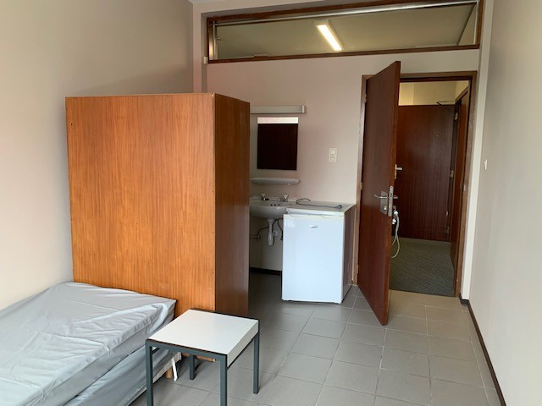
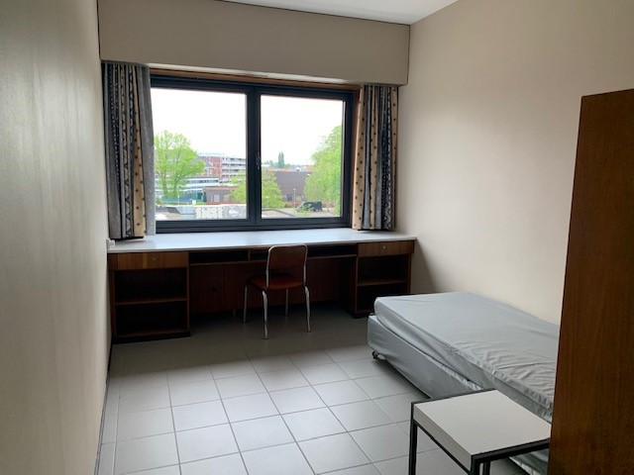
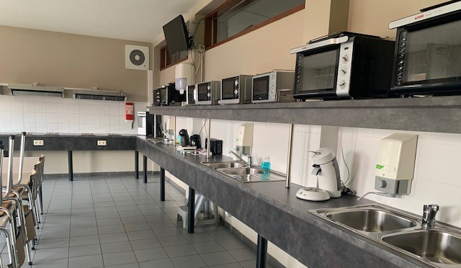
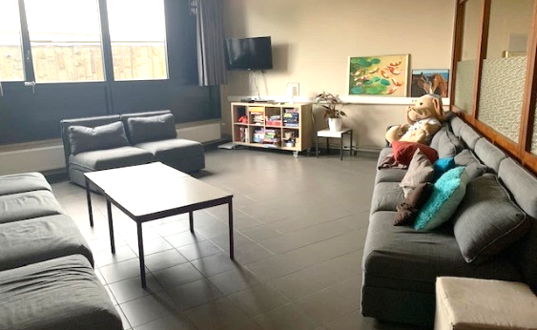

Option 2: Brugsken private market
Rent: € 330 + € 130 energy/water per month
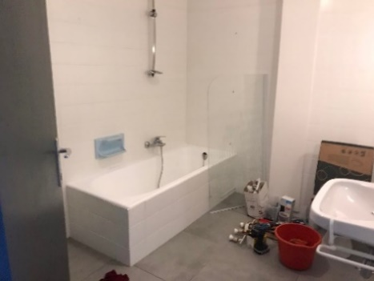
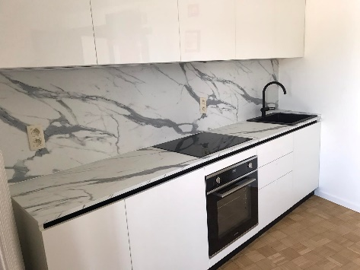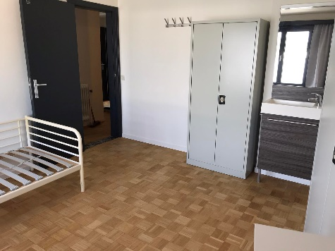
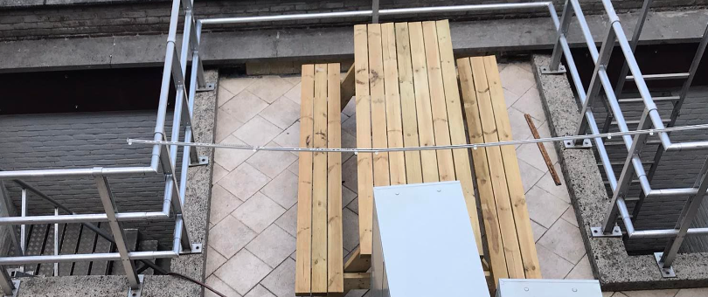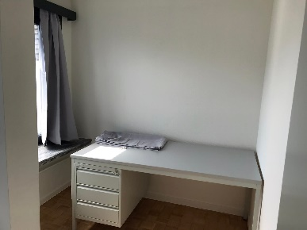
Option 3: Residential Care Center
- Rent: € 600/month (can be shared with 2 students in 1 appartment)
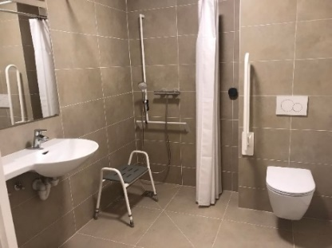
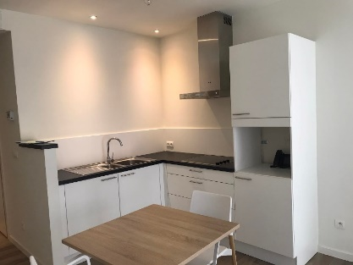
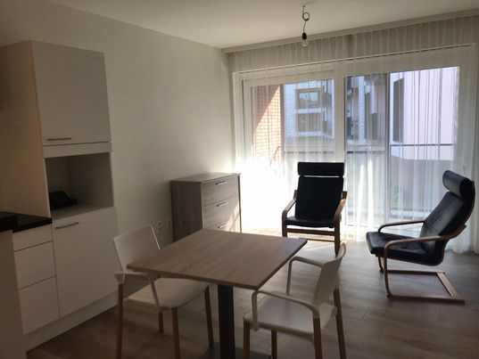
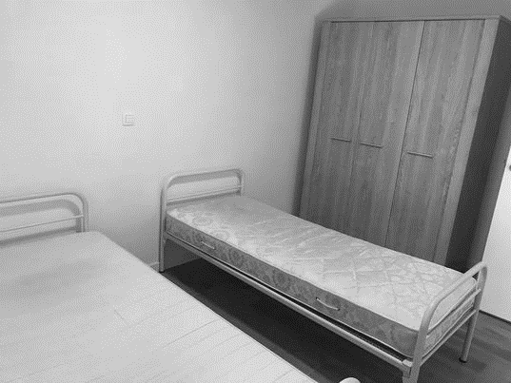
- + € 20/month for energy, water, wifi

As an international student you can rent an international student box for 15€, contact Els Van Eetvelt (els.vaneetvelt@odisee.be) if you want one. This box includes:
 | Kitchen |  | utensils |  |  |  |  |  | Bed stuff
2 | coffee cups |  | 1 big sauce pan + lid |  |  |  |  |  | 1 duvet
2 | water glasses |  | 1 small pot |  |  | 1 |  |  | pillow
2 | wine glasses |  | 1 cutlery holder |  |  | 1 |  |  | pillow cover
2 | small plates |  | 1 big pan |  |  | 1 |  |  | duvet cover
2 | big plates |  | 1 small pan |  |  | 1 |  |  | matress cover
2 | deep plates |  | big pot + lid
2 | forks |  | 2 spoons
2 | knives |  | 2 coffee spoons
You can also rent a bike via els.vaneetvelt@odisee.be for 30 euro. for
You are expected to bring your own :
- Toiletries, sheets and blankets (if you want an extra set)
- Cooking utensils and eating supplies (if you want additional things next to the international student box)
- Computer
- Alarm clock
- First-aid kit and medication,……

